DYNAMIC ROUTING AND POWER CONTROL IN WSNs
WITH K-MEANS AND Q-LEARNING USING
ARTIFICIAL INTELLIGENCE
PROJECT EVALUATION II REPORT
Submitted by
REENA S
SHREE HARINI S
SOUNDARYA AL
in partial fulfilment for the award of the degree
of
BACHELOR OF TECHNOLOGY
IN
COMPUTER SCIENCE AND BUSINESS SYSTEMS


K. RAMAKRISHNAN COLLEGE OF
ENGINEERING
(AUTONOMOUS)
SAMAYAPURAM, TRICHY

ANNA UNIVERSITY
CHENNAI 600 025

MARCH 2026

DYNAMIC ROUTING AND POWER CONTROL IN WSNs
WITH K-MEANS AND Q-LEARNING USING
ARTIFICIAL INTELLIGENCE
UCB1811 PROJECT EVALUATION II REPORT
Submitted by
REENA S (8115U22CB044)
SHREE HARINI S (8115U22CB050)
SOUNDARYA AL (8115U22CB052)
in partial fulfilment for the award of the degree
of
BACHELOR OF TECHNOLOGY
IN
COMPUTER SCIENCE AND BUSINESS SYSTEMS
Under the Guidance of
Mrs. P. UMA MAHESHWARI, M.E.,



COMPUTER SCIENCE AND BUSINESS SYSTEMS
K. RAMAKRISHNAN COLLEGE OF
ENGINEERING
(AUTONOMOUS)
Under
ANNA UNIVERSITY, CHENNAI


K. RAMAKRISHNAN COLLEGE OF ENGINEERING
(AUTONOMOUS)
Under
ANNA UNIVERSITY, CHENNAI

BONAFIDE CERTIFICATE
Certified that this project report “DYNAMIC ROUTING AND POWER CONTROL IN WSNs WITH K-MEANS AND Q-LEARNING USING ARTIFICIAL INTELLIGENCE” is the Bonafide work of “REENA S (8115U22CB044), SHREE HARINI S (8115U22CB050), SOUNDARYA AL (8115U22CB052)”who carried out the project work under my supervision.

Dr. J. SASIDEVI, M.E., Ph.D.,  Associate Professor  HEAD OF THE DEPARTMENT  Department of Computer Science and Business Systems  K. Ramakrishnan College of Engineering, (Autonomous)  Samayapuram, Trichy-621112. | Mrs. P. UMA MAHESHWARI, M.E.,  Assistant Professor  SUPERVISOR  Department of Computer Science and Business Systems  K. Ramakrishnan College of Engineering, (Autonomous)  Samayapuram, Trichy-621112.

SIGNATURE OF INTERNAL EXAMINER SIGNATURE OF EXTERNAL EXAMINER
NAME : NAME :
DATE : DATE :



K. RAMAKRISHNAN COLLEGE OF ENGINEERING
(AUTONOMOUS)
Under
ANNA UNIVERSITY, CHENNAI
ACKNOWLEDGMENT
We thank the almighty GOD, without whom it would not have been possible for us to complete our project.
We wish to address our profound gratitude to Dr. K. RAMAKRISHNAN, Chairman, K. Ramakrishnan College of Engineering (Autonomous), who encouraged and gave us all help throughout the course.
We express our hearty gratitude and thanks to our honorable and grateful Executive Director Dr. S. KUPPUSAMY, B.Sc., MBA., Ph.D., K.Ramakrishnan College of Engineering (Autonomous).
We are glad to thank our Principal Dr. D. SRINIVASAN, M.E., Ph.D., FIE., MIIW., MISTE., MIS, AE., C.Eng., K.Ramakrishnan College of Engineering (Autonomous), for giving us permission to carry out this project
We wish to convey our sincere thanks to Dr. J. SASIDEVI, M.E., Ph.D., Head of the Department of Computer Science and Business Systems, K. Ramakrishnan College of Engineering (Autonomous), for giving us constant encouragement and advice throughout the course.
We are grateful to Mrs. P. UMA MAHESHWARI, M.E., Assistant Professor in Computer Science and Business Systems, K. Ramakrishnan College of Engineering (Autonomous), for her guidance and valuable suggestions during the course of study.
We sincerely thank, Mrs. B. SATHIYA, M.TECH., for outstanding leadership and dedication throughout coordinating the project.
Finally, we sincerely acknowledge in no less terms all our staff members, colleagues, parents and friends for their cooperation and help at various stages of this project work.



K.RAMAKRISHNAN COLLEGE OF ENGINEERING
(AUTONOMOUS)
Under
ANNA UNIVERSITY, CHENNAI

DECLARATION BY THE CANDIDATE

I declare that to the best of my knowledge the work reported here in has been composed solely by myself and that it has not been in whole or in part in any previous application for a degree.

Submitted for the project Viva-Voce held at K. Ramakrishnan College of Engineering on

SIGNATURE OF THE CANDIDATE
(REENA S)

v



K.RAMAKRISHNAN COLLEGE OF ENGINEERING
(AUTONOMOUS)
Under
ANNA UNIVERSITY, CHENNAI

DECLARATION BY THE CANDIDATE

I declare that to the best of my knowledge the work reported here in has been composed solely by myself and that it has not been in whole or in part in any previous application for a degree.

Submitted for the project Viva-Voce held at K. Ramakrishnan College of Engineering on

SIGNATURE OF THE CANDIDATE
(SHREE HARINI S)

vi



K.RAMAKRISHNAN COLLEGE OF ENGINEERING
(AUTONOMOUS)
Under
ANNA UNIVERSITY, CHENNAI

DECLARATION BY THE CANDIDATE

I declare that to the best of my knowledge the work reported here in has been composed solely by myself and that it has not been in whole or in part in any previous application for a degree.

Submitted for the project Viva-Voce held at K. Ramakrishnan College of Engineering on

SIGNATURE OF THE CANDIDATE
(SOUNDARYA AL)

vii
ABSTRACT
Wireless Sensor Networks are used in environmental monitoring, healthcare, industrial automation, and smart cities. Since sensor nodes have limited battery power, low communication range, and minimal processing capability, managing energy efficiently is crucial for longer network lifetime. This research introduces an AI-based approach that combines K-means clustering with Q-learning for intelligent routing and dynamic power control. K-means forms energy-efficient clusters to reduce unnecessary communication, while Q-learning learns the best routing paths and adjusts transmission power based on network conditions and battery levels. This makes the network adaptive and capable of improving its performance over time. When compared with traditional methods like LEACH and its multi-hop versions, as well as recent energy-efficient techniques, the proposed method shows major improvements in active node count, energy usage, remaining battery power, and successful packet delivery to the base station. The advantages are more noticeable in large networks with many nodes. Overall, the combination of machine learning and classical communication techniques creates a more stable, efficient, and long-lasting Wireless Sensor Network for future smart environments, with strong adaptability to dynamic topology changes and varying traffic loads, reduced packet loss under harsh conditions, high scalability as node density increases, minimal computational overhead suitable for low-power devices, and strong potential for deployment in complex and evolving ecosystems.

viii
 | TABLE OF CONTENTS
CHAPTER  NO | TITLE | PAGE  NO
 | ABSTRACT | viii
 | LIST OF FIGURES | xii
 | LIST OF ABBREVIATIONS | xiii
1 | INTRODUCTION | 1
 | 1.1 Wireless Sensor Networks (WSNs) | 1
 | 1.2 Technologies Used | 1
 | 1.3 Applications | 2
 | 1.4 Feature Engineering in WSN Optimization | 3
 | 1.5 Hyperparameter Optimization | 4
 | 1.6 Normalization | 4
2 | LITERATURE SURVEY | 5
3 | SYSTEM ANALYSIS | 8
 | 3.1 Existing System | 8
 | 3.2 Disadvantages of the Existing Methods | 9
 | 3.3 Proposed System | 10
 | 3.4 Advantages of the Proposed System | 11
 | 3.5 Architecture Diagram | 12
4 | SYSTEM REQUIREMENTS | 14
 | 4.1 Hardware Requirements | 14
 | 4.2 Software Requirements | 14
 | 4.3 Software Description | 14
ix
5 | MODULE DESCRIPTION | 18
 | 5.1 Data Collection and Initialization Process | 18
 | 5.2 K-Means Clustering Module | 19
 | 5.3 Q-Learning Based Routing Module | 20
 | 5.4 Energy Consumption Calculation Analysis | 20
 | 5.5 Performance Evaluation Module | 21
 | 5.6 Results Visualization and Analysis Module | 21
6 | SYSTEM DESIGN | 25
 | 6.1 Flowchart | 25
 | 6.2 Class Diagram | 26
 | 6.3 Sequence Diagram | 27
7 | SYSTEM IMPLEMENTATION | 28
 | 7.1 System Architecture Overview | 28
 | 7.2 Hardware Implementation | 28
 | 7.2.1 Core Components | 28
 | 7.2.2 Deployment Options | 29
 | 7.3 Software Implementation | 29
 | 7.3.1 Core Software Stack | 29
 | 7.4 Implementation Steps | 30
 | 7.4.1 Dataset Preparation | 30
 | 7.4.2 K-Means Clustering Implementation | 30
 | 7.4.3 Q-Learning Routing Implementation | 30
 | 7.4.4 Performance Evaluation | 30
 | x
8 | SYSTEM TESTING | 31
 | 8.1 Accuracy Testing | 31
 | 8.2 Energy Efficiency Testing | 31
 | 8.3 Network Performance Testing | 32
9 | CONCLUSION AND FUTURE  ENHANCEMENTS | 33
 | 9.1 Conclusion | 33
 | 9.2 Result Analysis | 34
 | 9.3 Future Enhancements | 34
 | APPENDICES | 35
10 | REFERENCE | 42
 | CERTIFICATES

xi
LIST OF FIGURES

FIGURE NO | FIGURE NAME | PAGE NO
3.1 | Existing System Architecture | 8
3.3 | Proposed System Block Diagram | 11
3.5 | Architecture Diagram | 13
5.1 | Dataset | 19
5.6 | Result Validation and Analysis | 22
6.1 | Flow Chart | 25
6.2 | Class Diagram | 26
6.3 | Sequence Diagram | 27

xii
LIST OF ABBREVIATIONS
ABBREVIATIONS | EXPANSION
WSN / WSNs | Wireless Sensor Network(s)
LEACH | Low Energy Adaptive Clustering Hierarchy
DMHT-LEACH | Distributed Multi-Hop Transmission LEACH
EDMHT-LEACH | Enhanced Distributed Multi-Hop Transmission LEACH
EEMLCR | Energy-Efficient Machine Learning-based Clustering and Routing
EECDA | Energy Efficient Clustering and Data Aggregation
CMML | Cluster-based Multi-hop Machine Learning Routing
CH | Cluster Head
BS | Base Station
PDR | Packet Delivery Ratio

xiii
CHAPTER 1
INTRODUCTION
1.1 WIRELESS SENSOR NETWORKS (WSNs)
Wireless Sensor Networks (WSNs) are distributed systems made up of many low-power sensor nodes that can sense, process, and transmit data over wide areas. They are widely used in fields such as environmental monitoring, industrial automation, smart agriculture, disaster management, and military surveillance. A typical WSN includes sensor nodes, cluster heads, and a base station that receives and processes the collected information.
However, WSNs face major challenges due to limited battery power, short communication ranges, and low processing capability. Since sensor nodes are battery-operated and often deployed in remote or hazardous areas, replacing or recharging them is difficult. Therefore, energy efficiency becomes the most important factor in determining network lifetime. To address this, intelligent clustering and energy-aware routing strategies are needed. While traditional protocols like LEACH offer basic energy-saving features, they struggle to adapt to dynamic network conditions, highlighting the need for scalable, adaptive, and learning-based solutions.
1.2 TECHNOLOGIES USED
1.2.1 K-Means Clustering
Used for grouping sensor nodes into clusters based on their physical location. It helps minimize intra-cluster communication distance and balances energy usage.
1
1.2.2 Q-Learning (Reinforcement Learning)
A learning-based routing strategy that enables cluster heads to choose energy-efficient paths dynamically. The model improves routing decisions through continuous learning.

1.2.3 Wireless Communication Protocols
Energy models and communication standards define how nodes transmit, receive, and aggregate data, ensuring efficient network operation.
1.2.4 Simulation Frameworks
Tools such as Python, MATLAB, or NS-3 enable modeling, visualization, and performance evaluation of clustering and routing algorithms.
1.2.5 Energy Models
The first-order radio model calculates energy consumed during transmission, reception, and data aggregation, helping evaluate system performance.
1.3 APPLICATIONS
Energy-efficient clustering and routing in WSNs have broad real-world applications:
- Smart Agriculture
Monitoring soil moisture, temperature, and crop growth efficiently over long durations.
- Environmental Monitoring
Tracking pollution levels, forest fires, water quality, wildlife movements.
2
- Industrial Automation
Supervising equipment health, machine vibrations, and gas leak detections.
- Smart Cities
Managing street lighting, traffic systems, and waste management with low-energy sensors.
- Military and Border Security
Monitoring strategic zones where sensor replacement is difficult.
1.4 FEATURE ENGINEERING IN WSN OPTIMIZATION
The clustering and routing rely largely on algorithmic operations, certain features must be extracted or computed for efficient functioning.
- Distance Calculation
Used to assign nodes to clusters and estimate transmission energy.
- Residual Energy Tracking
Helps determine eligible cluster heads and route-quality metrics.
- Node Density and Neighbor Count
Influence cluster size and routing efficiency.
- State Representation for Q-Learning:
Converts raw measurements (energy, distance, hops) into meaningful states.

3
1.5 HYPERPARAMETER OPTIMIZATION
1.5.1 Learning Rate (α) in Q-Learning
Determines how quickly the routing agent updates its knowledge.
1.5.2 Discount Factor (γ)
Balances immediate energy savings with long-term network benefits.
1.5.3 Exploration Rate (ε)
Controls the trade-off between exploring new routes.
1.5.4 Number of Clusters (K)
Impacts cluster size, energy consumption, and communication overhead.
1.5.5. Cluster Interval
Determines how frequently clusters should be rebuilt to adapt to network.
1.6 NORMALIZATION
Normalization ensures uniform scaling and stability of data used in clustering and routing:
- Coordinate Normalization: Scaling node positions ensures that clustering remains consistent across varying network sizes.
- Energy Normalization: Residual energy values are often normalized between 0 and 1 to simplify decision-making.
- Routing State Normalization: Input features for Q-learning (distance, hops, energy) are normalized to maintain balanced learning.
4
CHAPTER 2
LITERATURE SURVEY

2.1 Q-Learning-Based Data-Aggregation-Aware Energy-Efficient Routing
Protocol for Wireless Sensor Networks
AUTHORS: WAN-KYU YUN AND SANG-JO YOO
YEAR OF PUBLICATION: 2021
A Q-learning-based, data-aggregation-aware, energy-efficient routing protocol for Wireless Sensor Networks (WSNs), where energy consumption critically impacts network lifetime. To reduce redundant transmissions, the method applies sensor-type-dependent data aggregation and uses reinforcement learning to select optimal routes based on aggregation efficiency, communication cost, and residual energy. By maximizing these rewards, the protocol avoids low-energy nodes and identifies effective forwarding paths. Simulation results show that the proposed approach significantly reduces data volume and improves overall network lifetime compared to conventional energy-aware routing schemes.
2.2 EEMLCR: Energy-Efficient Machine Learning-Based Clustering and
Routing for Wireless Sensor Networks
AUTHORS: MUHAMMAD AKRAM, SIBGHAT ULLAH BAZAI, MUHAMMAD IMRAN
YEAR OF PUBLICATION: 2025
An Energy-Efficient Machine Learning-Based Clustering and Routing method for Wireless Sensor Networks (WSNs). Due to the limited power, communication range, and processing capability of sensor nodes, clustering and efficient routing are essential for reducing energy consumption. EEMLCR applies K-means clustering and Q-learning to automate cluster formation and routing path selection. The method is evaluated against LEACH and its multi-hop variants (DMHT-LEACH and EDMHT-LEACH), showing significant improvements in alive node count, energy usage, remaining battery power, and packet reception after 600 rounds in a 400-node network. Comparisons with recent algorithms such as EECDA and CMML further confirm its competitive or superior performance in terms of network lifetime and energy efficiency. Overall, EEMLCR demonstrates how machine learning can optimize clustering and routing, leading to more energy-efficient and longer-lasting WSN deployments.
5
2.3 Integration of artificial intelligence (AI) with sensor networks: Trends,
challenges, and future directions
AUTHORS: SALIM EL KHEDIRI, AWATEF BENFRADJ
YEAR OF PUBLICATION: 2024
Artificial Intelligence (AI) can enhance Wireless Sensor Networks (WSNs), which are traditionally configured statically and difficult to adapt dynamically. Integrating AI, including machine learning and reinforcement learning, can improve energy management, reduce waste, and extend the lifespan of WSN and IoT devices. The paper reviews supervised, unsupervised, and reinforcement learning techniques applied to WSNs , offering researchers a clear overview of recent advancements. It also analyzes the strengths and limitations of current AI-based approaches, highlights ongoing challenges, and outlines future directions for achieving more sustainable and adaptable WSN solutions.
6
2.4 An Energy-Efficient Scheduling and Routing Protocol Based on Q-Learning
for WSN
AUTHORS: HUDA SALIH ABD, ASAAD S DAGHUL
YEAR OF PUBLICATION: 2025
Nodes make forwarding decisions using local energy, distance, and link-quality information, while sleep mode reduces unnecessary communication. Compared with LEACH and the proposed method performs better in all metrics, proving the value of combining learning-based routing with adaptive clustering for longer WSN lifetime. This work presents an energy-efficient WSN routing protocol that integrates dynamic K-means clustering, Q-learning routing, and adaptive sleep scheduling.
2.5 Reinforcement Learning for Tackling Energy-saving and Energy-balance
Dilemma of Cluster-based Routing Protocols in WSNs
AUTHORS: YAN WANG, KE DENG, YONGLI REN, JEFFREY CHAN
YEAR OF PUBLICATION: 2024
Tackles the long-standing energy-saving and energy-balance dilemma in cluster-based routing protocols for Wireless Sensor Networks (WSNs). Instead of introducing a new routing protocol, the authors employ reinforcement learning to enhance existing ones by making two key decisions each round: whether reclustering is necessary and which cluster-heads should be excluded from multi-hop relaying. These adaptive decisions help reduce energy consumption while evenly distributing energy usage across nodes. Experimental results demonstrate that the reinforcement learning–based approach significantly improves energy efficiency and energy balance compared to traditional methods, thereby extending the operational lifespan of WSNs
7
CHAPTER 3
SYSTEM ANALYSIS
3.1 EXISTING SYSTEM

SENSOR NODE
- Sensing
- Sends Data CH
SENSOR NODE
- Sensing
- Sends Data CH
SENSOR NODE
- Sensing
- Sends Data CH

Intra-cluster Data



Direct Routing
Cluster head (CH)
- Probabilistic
Selection
- Data Aggregation

BASE STATION
BASE STATION
- Collects Data
- Central Processing

Fig 3.1. EXISTING SYSTEM ARCHITECTURE

• Wireless Sensor Networks (WSNs) are widely used in environmental monitoring, industrial automation, military systems, and smart cities. Although protocols like LEACH, DMHT-LEACH, and EDMHT-LEACH aim to save energy through clustering, they rely on static or probabilistic rules that do not adjust to changing energy levels, network density, or communication distances.
8
• Lack of intelligent and adaptive decision-making leads to inefficient cluster formation and routing. Low-energy nodes may still be chosen as cluster heads, causing early energy depletion, uneven load distribution, and reduced network lifetime. Traditional methods also fail to optimize routing paths using learning-based techniques.
• Limited support for adaptive multi-hop routing results in suboptimal communication, higher energy usage, and greater packet loss in large-scale deployments. This causes static behaviour, inefficient energy usage, and poor scalability in current WSN systems.
3.2 DISADVANTAGES OF EXISTING METHODS
Static Routing Decision
Traditional protocols like LEACH use predefined rules that do not adapt to changing energy levels or network topology.
Uneven Energy Consumption
Some nodes become overburdened, resulting in early energy depletion and reduced network lifetime.
Limited Scalability
Existing algorithms struggle when node count increases, causing performance degradation.
9
Lack of Learning-Based Optimization
No mechanism exists to learn from previous routing decisions and improve future communication paths.
High Packet Loss
Long-distance communication without multi-hop optimization leads to data loss and inefficiency.
3.3 PROPOSED SYSTEM
• The proposed system, EEMLCR (Energy-Efficient Machine Learning-Based Clustering and Routing), introduces a hybrid machine learning-based approach to overcome the limitations of existing WSN protocols. This system integrates K-means clustering and Q-learning-based routing to intelligently manage energy consumption and extend network lifetime.
• In this system, K-means clustering is used to form energy-balanced clusters by grouping sensor nodes based on their spatial positions. This ensures that clusters are well distributed across the network. After cluster formation, cluster heads (CHs) are selected based on proximity to cluster centroids and residual energy, improving fairness and load distribution.
• Once the clusters are formed, Q-learning, a reinforcement learning technique, is used to determine the most energy-efficient routing paths from cluster heads to the base station. The learning agent continuously updates its routing policy based on energy consumption,
10
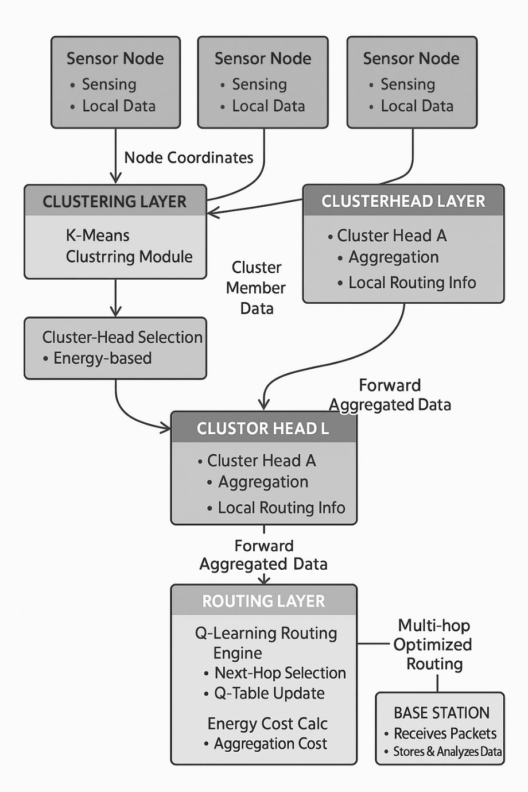
Fig 3.3. PROPOSED SYSTEM BLOCK DIAGRAM

3.4 ADVANTAGES OF THE PROPOSED SYSTEM
Higher Energy Efficiency
Adaptive learning reduces unnecessary transmissions and balances load among nodes.
11
Improved Network Lifetime
Effective CH rotation, multi-hop routing, and Q-learning ensure longer sensor operation.
Scalable Architecture
Suitable for dense and large-scale sensor deployments.
Better Packet Delivery Rate
Intelligent routing leads to reduced packet drops and improved reliable.
Dynamic Adaptability
Model learns from network behavior, adapting routes based on energy.

3.5 ARCHITECTURE DIAGRAM
3
The architecture diagram of the proposed EEMLCR system illustrates the complete workflow of clustering and routing in Wireless Sensor Networks using machine learning. The process begins with the deployment of sensor nodes across the monitoring area. Each node is initialized with its position, unique ID, and energy level.
The system first performs data preprocessing, where node attributes such as coordinates, neighbor lists, and residual energy are collected. These values are passed to the K-means clustering module, which groups nodes into optimal clusters. After clustering, the Cluster Head (CH) Election Module selects a CH for each cluster based on centroid closeness and available energy.
Once the CHs are selected, the system applies the Q-learning routing module. For each CH, a reinforcement learning agent evaluates possible next-hop nodes and selects the most energy-efficient route toward the base station.
12
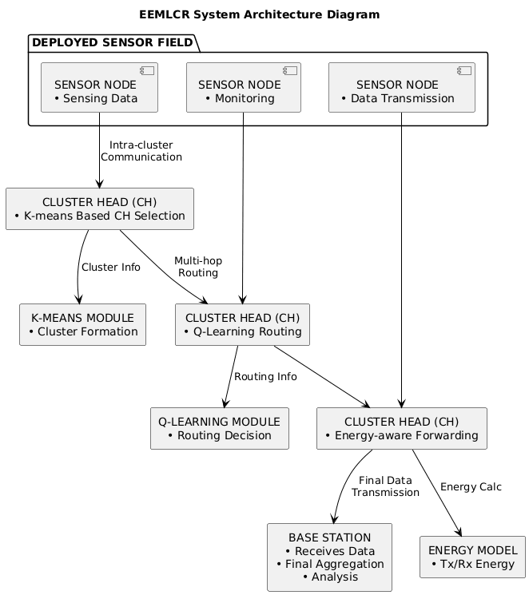

Fig 3.5. ARCHITECTURE DIAGRAM

13
CHAPTER 4
SYSTEM REQUIREMENTS
4.1 HARDWARE REQUIREMENTS
• Processor : Intel Core i3
• RAM : 4 GB
• Hard Disk : 10 GB
• Compact Disk : 650 MB
• Keyboard : Standard keyboard
• Monitor : 15 inch color monitor
• Internet : Required for Google Co-lab access

4.2 SOFTWARE REQUIREMENTS
• Operating System : Platform-independent
(accessible via any OS with internet, e.g., Windows, macOS, or Linux)
• Development Environment : Google Co-lab (cloud-based Jupyter Notebook)
• Programming Language : Python
• Libraries and Frameworks : NumPy, Pandas, Matplotlib, Seaborn
4.3 SOFTWARE DESCRIPTION
4.3.1 Software Used
Python is widely used in artificial intelligence, machine learning, and network simulations. It provides powerful tools for implementing algorithms such a
14
K-Means clustering and Q-Learning, which are used in this project for dynamic routing and power control in Wireless Sensor Networks (WSNs).
4.3.2 Python Technology

1. Rich Libraries and Frameworks
Python offers a wide range of libraries that support data processing, machine learning, and visualization, which are essential for implementing the proposed system. Examples include:
a.NumPy –Used for numerical computations and array operations required in clustering and reinforcement learning algorithms.
b.Scikit-learn –Provides machine learning algorithms such as K-Means clustering, which is used to group sensor nodes into clusters.
c.Matplotlib –Used to visualize network performance such as energy consumption, node lifetime, and routing paths.
d.Pandas –Helps in organizing and managing simulation data related to sensor nodes, energy levels, and routing information.

2. Ease of Learning and Use
Python has a simple and readable syntax that makes it easy to implement complex algorithms. Algorithms such as K-Means clustering and Q-Learning can be implemented efficiently using Python with fewer lines of code and better clarity.
15

3. Extensive Support for Artificial Intelligence
Python is one of the most widely used languages in artificial intelligence and machine learning research. It provides libraries and frameworks that support reinforcement learning and clustering techniques, making it suitable for implementing intelligent routing and power control mechanisms in WSNs.

4. Integration with Google Colab
Python integrates seamlessly with cloud platforms such as Google Colab, allowing developers to run programs without installing additional software locally. Google Colab provides a convenient environment for running Python code and executing machine learning algorithms with built-in libraries.

5. Community and Resources
Python has a large global community of developers and researchers. Numerous tutorials, documentation, and forums are available to help solve development challenges. This makes Python a reliable choice for implementing AI-based systems such as intelligent routing in wireless sensor networks.

How Python is Used in This Project
In the Dynamic Routing and Power Control in WSNs project, Python is used to:
•Generate and manage the dataset representing sensor node positions and energy levels.
•Implement K-Means clustering to group sensor nodes into clusters.
•Apply Q-Learning to determine optimal routing paths between nodes and the basestation.
•Simulate energy consumption and routing behavior in the network.
•Visualize results such as network lifetime, energy usage, and clustering performance using Matplotlib.
16
4.3.3 Google Co-Lab
Google Colab (short for Colaboratory) is a cloud-based interactive development environment used for executing Python programs. It is widely used for machine learning, artificial intelligence, and data analysis projects. For this project, Google Colab is used to simulate the Wireless Sensor Network environment and implement AI-based algorithms for routing and power control.

How Google Colab is Used in This Project

For the Dynamic Routing and Power Control in WSNs project, Google Colab is used in the following ways:
•Dataset Generation and Preprocessing: Sensor node data such as position coordinates and energy levels are generated and organized.
•Algorithm Implementation: K-Means clustering is implemented to form clusters among sensor nodes, while Q-Learning is used to determine optimal routing paths.
•Simulation and Training: The network simulation runs multiple iterations to analyze routing efficiency and power consumption.
•Performance Evaluation: Metrics such as network lifetime, energy consumption, and number of active nodes are evaluated.
•Visualization: Graphs and plots are generated to illustrate clustering results and network performance.
17
CHAPTER 5
MODULE DESCRIPTION
MODULES
5.1 Data Collection & Initialization Process
5.2 K-Means Clustering Module
5.3 Q-Learning-Based Routing Module
5.4 Energy Consumption Calculation Analysis
5.5 Performance Evaluation Module
5.6 Results Visualization & Analysis Module
5.1 Data Collection & Initialization Process
This module collects the initial parameters required to set up the Wireless Sensor Network (WSN). It initializes sensor node positions, energy levels, communication range, number of clusters, and base station location. The module ensures that all nodes are properly deployed and ready for clustering and routing operations.
Functions:
- Deploy sensor nodes randomly or in a grid
- Assign initial energy to each node
- Set simulation parameters (rounds, area size, threshold values)
- Define base station position
18
27
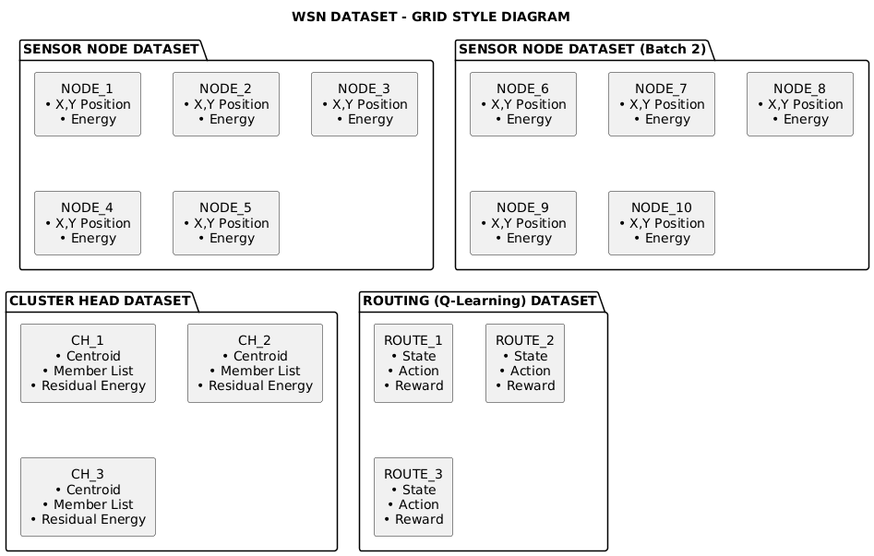
Fig 5.1. DATASET

5.2 K-Means Clustering Module
This module performs the clustering process using the K-means algorithm. It groups sensor nodes based on their spatial distribution to form energy-efficient and balanced clusters. The clustering aims to reduce communication distance and minimize intra-cluster energy consumption.
Functions:
- Calculate optimal number of clusters
- Assign nodes to nearest cluster centers
19
- Update cluster centroids iteratively
- Select cluster heads
- Form stable and energy-balanced clusters
5.3 Q-Learning-Based Routing Module
This module uses Q-learning to determine the most energy-efficient routing path from each cluster head to the base station. It allows cluster heads to learn and adapt their routing strategies based on network conditions.
Functions:
- Initialize Q-table for each cluster head
- Define states (energy level, distance, neighbor status)
- Define actions (choose next-hop node)
- Apply reward function based on energy saving & successful delivery
- Update Q-values using reinforcement learning
- Select optimal multi-hop routing path
5.4 Energy Consumption Calculation Analysis
This module calculates the energy consumed during data transmission, reception, aggregation, and routing. It uses the radio energy model to accurately measure energy usage across the network.
Functions:
- Compute transmission energy
- Compute reception energy
20
- Apply data aggregation cost at cluster heads
- Update remaining energy of all nodes
- Track total energy consumption per round
5.5 Performance Evaluation Module
This module evaluates the efficiency of the proposed EEMLCR method. It compares the performance with benchmark algorithms such as LEACH, DMHT-LEACH, EDMHT-LEACH, EECDA, and CMML.
Performance Metrics:
- Number of alive nodes
- Average remaining energy
- Energy consumption per round
- Packet delivery ratio
- Network lifetime (stability period & instability period)
5.6 Results Visualization & Analysis Module
This module generates graphs, statistics, and visualization plots to analyze the performance .
Outputs:
- Alive nodes vs. rounds graph
- Remaining energy vs. rounds graph
- Packet received vs. rounds graph
- Comparison graphs with LEACH family & state-of-the-art algorithms
21
30
Simulation output data
•Alive/dead nodes
•Avg energy
•Throughput
•Q-Learning rewards

Validate Simulation
Result Validation Modules
•Data checking
•Consistency Check
•Accuracy Evaluation

Pass Confirmed Data
Analysis comparison engine
•EEMLCR VS LEACH
•EEMLCR VS EDMHT

Generate Graphs and Metrics
Final result output
•Performance Graphs
•Tables
•Network improvement
•Summary Report

Fig 5.6. RESULT VALIDATION AND ANALYSIS

22

Simulation Output Data
This stage represents the raw results produced after running the network simulation. The simulation generates several key metrics that describe the system’s behavior and performance, including the number of alive and dead nodes, the average residual energy remaining in the network, the throughput achieved, and the Q-learning reward values when reinforcement learning is used. These parameters collectively reflect how energy-efficient, stable, and reliable the simulated protocol is. At this point, the data is not yet verified, but it provides the essential foundation on which further analysis will be built.

Validate Simulation
Before analysis, the simulation results must undergo a validation step to ensure they accurately represent the intended experiment. This stage checks that the simulation ran correctly, that all expected output metrics are present, and that no unexpected behavior occurred due to bugs or incorrect parameters. Validation ensures the trustworthiness of the simulation environment and prevents the propagation of errors into later stages of analysis. Only after the simulation is confirmed to be performed correctly can the results move to deeper verification.

Result Validation Modules
This block performs detailed verification using three internal procedures: data checking, consistency check, and accuracy evaluation. Data checking ensures the presence and completeness of all output values, while consistency checking verifies that the data follows logical and expected trends—such as gradual energy depletion and progressive node failure over time.
23

Analysis Comparison Engine
After the data is confirmed, it is fed into the analysis comparison engine, where the performance of the proposed protocol is compared against benchmark methods. The flowchart highlights comparisons such as EEMLR versus LEACH and EEMLCR versus EDMHT-LEACH. These comparisons allow researchers to assess improvements in network lifetime, energy efficiency, and throughput under the same simulated conditions. By evaluating the proposed method against both classical and advanced protocols, this stage demonstrates the relative advantages and effectiveness of the new approach.

Generate Graphs and Metrics
Once comparative analysis is complete, the system generates visual and numerical outputs to represent performance trends. This includes graphs that illustrate metrics such as node survival, energy usage, and throughput over simulation rounds. It may also produce statistical summaries and computed performance indicators. These visuals and metrics make it easier for readers to interpret results, identify trends, and appreciate the improvements offered by the proposed method. This step prepares the information for reporting and documentation.

Final Result Output
The final stage compiles all the validated data, analysis results, graphs, and metrics into a structured output package. This includes performance graphs, summary tables, documented improvements in network lifetime, and a concise summary report explaining the findings. The finalized materials are then ready for inclusion in the thesis or publication.
24
CHAPTER 6
SYSTEM DESIGN
6.1 FLOWCHART
The flowchart represents the working process of the proposed system. The process begins with the deployment of sensor nodes in the network area.
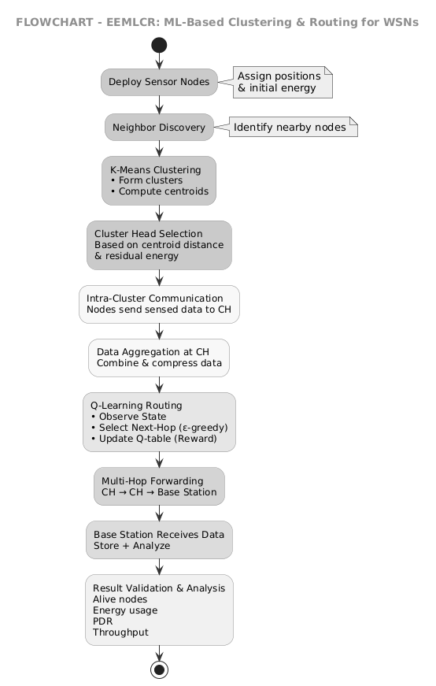

25
Fig 6.1. FLOWCHART

6.2 CLASS DIAGRAM
The class diagram shows the main components used in the system. The Node class contains attributes such as ID, position, and energy. The Cluster class manages cluster members and CH selection. The Cluster Head class extends the Node class and contains additional functions for aggregation and Q-learning.

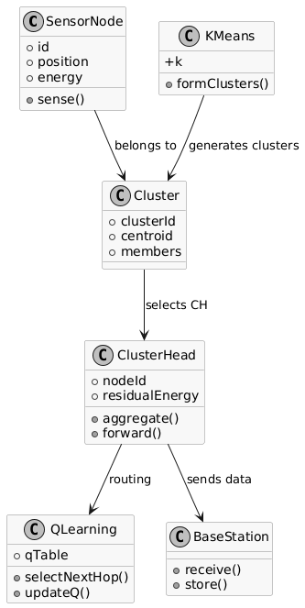
Fig 6.2. CLASS DIAGRAM
26
6.3 SEQUENCE DIAGRAM
The sequence diagram explains the order of operations in a single simulation round. The simulator calls the K-means module to form clusters. Each cluster elects its CH Sensor nodes sense data and send it to the CH. The CH aggregates the data and requests the Q-learning agent to select the next hop.
A sequence diagram is a type of Unified Modeling Language diagram that visually represents the interactions between objects or system components in a chronological order to carry out a specific function or scenario. Time progresses from top to bottom, and messages are exchanged horizontally between vertical lifelines.
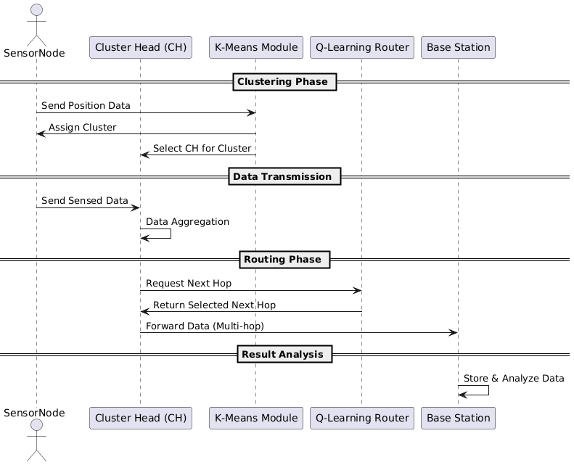
27
Fig 6.3. SEQUENCE DIAGRAM
CHAPTER 7
SYSTEM IMPLEMENTATION

7.1 SYSTEM ARCHITECTURE OVERVIEW
The proposed system implements an intelligent routing and power control mechanism for Wireless Sensor Networks (WSNs) using K-Means clustering and Q-Learning algorithms. The system aims to improve network lifetime and reduce energy consumption by dynamically selecting optimal routing paths and cluster heads.
Sensor Node Deployment → Dataset Preparation → K-Means Clustering → Q-Learning Routing → Performance Evaluation

7.2 HARDWARE IMPLEMENTATION
7.2.1 Core Components
Processing Unit: Intel Core i3.
Memory (RAM): Minimum 4 GB RAM for handling data processing.
Storage: At least 256 GB SSD for storing project files, datasets, and results.
Network Connectivity: Stable internet connection for (Google Colab).
Display System: Standard monitor for visualizing graphs and simulation results.
28

7.2.2 Deployment Options
Standalone System: Runs on a single computer using Python or Google Colab.
Cloud-Based Deployment: Executed in the cloud using Google Colab.
Research Simulation Environment: Used for large-scale WSN performance.

7.3 SOFTWARE IMPLEMENTATION
7.3.1 Core Software Stack
Operating System: accessible via any OS with internet, e.g., Windows, macOS, Linux.
Programming Language: Python.
Development Environment: Google Colab.
Supporting Computing Libraries:
•NumPy – Used for numerical computations and array operations.
•Pandas – Used for organizing and managing simulation datasets.
•Matplotlib – Used for visualizing network performance graphs.
•Random Library – Used for generating random sensor node positions.

29
7.4 IMPLEMENTATION STEPS

7.4.1 Dataset Preparation

In this step, the Wireless Sensor Network dataset is generated by randomly deploying sensor nodes in a defined area. Each node is assigned parameters such as node ID, coordinates, and initial energy. The base station location is also defined for routing communication.

7.4.2 K-Means Clustering Implementation
The K-Means algorithm groups sensor nodes into clusters based on their positions. Cluster centroids are calculated and nodes are assigned to the nearest cluster. Cluster heads are then selected to collect and forward data from member nodes.

7.4.3 Q-Learning Routing Implementation

Q-Learning is used to determine the optimal routing path between cluster heads and the base station. The algorithm updates routing decisions based on rewards related to energy efficiency and successful data transmission.

7.4.4 Performance Evaluation

The system performance is analyzed using metrics such as network lifetime, energy consumption, number of alive nodes, and packet delivery ratio. Graphs are generated to visualize and evaluate the efficiency of the proposed system.

30
CHAPTER 8
SYSTEM TESTING

8.1 ACCURACY TESTING
Purpose:
To verify the accuracy of clustering and routing decisions using K-Means and Q-Learning algorithms.
Method:
The system is tested by running simulations with multiple sensor nodes and observing cluster formation and routing paths.
Example:
If clusters are formed correctly and efficient routing paths are selected in most simulation rounds, the system is considered accurate.

8.2 ENERGY EFFICIENCY TESTING
Purpose:
To measure how effectively the proposed system reduces energy consumption in the network.
Method:
Energy levels of sensor nodes are monitored during simulation and compared across rounds.
31
Example:
If nodes retain higher energy and the network operates longer, the system shows better energy efficiency.

8.3 NETWORK PERFORMANCE TESTING
Purpose:
To evaluate the overall performance of the Wireless Sensor Network.
Method:
Metrics such as number of alive nodes, packet delivery ratio, and network lifetime are analyzed.
Example:
If more nodes remain active and packets reach the base station successfully, network performance is improved.

32
CHAPTER 9
CONCLUSION AND FUTURE ENHANCEMENT

9.1 CONCLUSION
The proposed Energy-Efficient Machine Learning-Based Clustering and Routing method combines K-means clustering with Q-learning-based routing to effectively address the challenges of energy consumption and network longevity in wireless sensor networks. By integrating intelligent cluster formation with adaptive routing decisions, the method offers a dynamic and scalable solution for improving communication in resource-limited sensor environments. Implemented in MATLAB and evaluated across different network sizes, it demonstrates significant improvements over traditional routing techniques such as LEACH and its multi-hop variants, showing reduced energy usage, a higher number of active sensor nodes, and enhanced overall network stability. The results also indicate that the approach performs even better in larger deployments, extending network lifetime and improving operational efficiency, which confirms the value of applying machine learning techniques to wireless sensor communication. This research shows that learning-based methods can substantially improve sensor network performance by enabling more efficient clustering and smarter routing. The gains achieved in energy conservation and operational durability highlight the method’s potential as a reliable and effective solution for modern sensor-based applications. Future work may further enhance this approach by exploring additional learning models, incorporating node mobility, or integrating real-time environmental factors to achieve even greater optimization.
33
9.2 RESULT ANALYSIS
The proposed system applies K-Means clustering and Q-Learning algorithms to improve routing and energy efficiency in Wireless Sensor Networks. Simulation results show that the method reduces energy consumption and increases network lifetime. The clustering process balances the load among nodes, while Q-Learning selects optimal routing paths. Performance graphs indicate that more sensor nodes remain active for longer rounds and packet delivery is improved. Overall, the AI-based approach enhances network performance compared to traditional routing protocols.

9.3 FUTURE ENHANCEMENTS
The proposed system can be further improved by integrating advanced artificial intelligence techniques. One possible enhancement is the use of Deep Q-Learning to provide more intelligent routing decisions and improve learning capability in complex network environments. Support for mobile sensor nodes can also be introduced so that the system can adapt to dynamic network topologies. Future work may also include integration with IoT cloud platforms for real-time monitoring and large-scale deployment of wireless sensor networks. Additionally, implementing adaptive sleep scheduling mechanisms can help reduce unnecessary energy usage by allowing sensor nodes to enter low-power states when they are not actively transmitting data. These improvements can further enhance network lifetime, reliability, and overall efficiency of the system.

34
APPENDICES
APPENDIX (A) SAMPLE CODING
Upload Dataset in Google Colab
from google.colab import files
uploaded = files.upload()

Import Required Libraries
import pandas as pd
import numpy as np
import matplotlib.pyplot as plt
from sklearn.cluster import KMeans

MODULE 1: Data Collection & Initialization Process
data = pd.read_csv("WSN_Dataset.csv")
data.head()

Visualize Node Deployment
plt.figure(figsize=(6,6))
plt.scatter(data['x'], data['y'], c='lightblue', label='Sensor Nodes')
plt.scatter(base_station['x'], base_station['y'], c='red', marker='*', s=200, label='Base Station')
plt.title("WSN Node Deployment")
plt.xlabel("X")
plt.ylabel("Y")
plt.legend()
plt.grid()
plt.show()

MODULE 2: K-Means Clustering Module
kmeans = KMeans(n_clusters=NUM_CLUSTERS, random_state=42)
data['cluster'] = kmeans.fit_predict(data[['x', 'y']])

Visualize Clusters & Cluster Heads
plt.figure(figsize=(6,6))

for i in range(NUM_CLUSTERS):
cluster_nodes = data[data['cluster'] == i]
plt.scatter(cluster_nodes['x'], cluster_nodes['y'], label=f'Cluster {i}')
35
# Plot Cluster Heads
plt.scatter(
data[data['is_CH']]['x'],
data[data['is_CH']]['y'],
c='black', marker='X', s=200, label='Cluster Heads'
)

plt.scatter(base_station['x'], base_station['y'], c='red', marker='*', s=250, label='Base Station')

plt.title("K-Means Clustering with Cluster Head Selection")
plt.xlabel("X")
plt.ylabel("Y")
plt.legend()
plt.grid()
plt.show()

MODULE 3: Q-Learning Based Routing Module
# Get indices of cluster heads
CH_nodes = data[data['is_CH'] == True].index.tolist()
CH_nodes

Find Best Route
best_paths = {}

for ch in CH_nodes:
path = [ch]
current = ch

for _ in range(10):
next_node = np.argmax(Q_table[current])
path.append(next_node)
current = next_node

bs_dist = math.sqrt((data.loc[current,'x']-base_station['x'])**2 +
(data.loc[current,'y']-base_station['y'])**2)
if bs_dist < 15:
break

best_paths[ch] = path

best_paths
36

MODULE 4: Energy Consumption Calculation Analysis

def transmit_energy(d):
return (E_elec * packet_size) + (E_amp * packet_size * (d**2))

Check Alive Nodes
alive_nodes = data[data['energy'] > 0]
dead_nodes = data[data['energy'] <= 0]

print("Alive Nodes:", len(alive_nodes))
print("Dead Nodes:", len(dead_nodes))

MODULE 5: Performance Evaluation Module
# Add status column
data['status'] = 'ACTIVE'

SLEEP_THRESHOLD = 20 # energy threshold

for i in range(len(data)):

# Cluster Heads always active
if data.loc[i, 'is_CH'] == True:
data.loc[i, 'status'] = 'ACTIVE'

else:
# Low energy nodes go to sleep
if data.loc[i, 'energy'] < SLEEP_THRESHOLD:
data.loc[i, 'status'] = 'SLEEP'
else:
# Random sleep scheduling (30%)
if np.random.rand() < 0.3:
data.loc[i, 'status'] = 'SLEEP'
else:
data.loc[i, 'status'] = 'ACTIVE'

Check Active and Sleep Nodes
active_nodes = len(data[data['status'] == 'ACTIVE'])
sleep_nodes = len(data[data['status'] == 'SLEEP'])

print("Active Nodes:", active_nodes)
print("Sleep Nodes:", sleep_nodes)
37

MODULE 6: Results Visualization & Analysis Module
rounds = 20
alive_history = []

for r in range(rounds):

print("Round:", r+1)

# ---- Sleep Scheduling ----
for i in range(len(data)):
if data.loc[i, 'is_CH'] == False:
if data.loc[i, 'energy'] < 10:
data.loc[i, 'status'] = 'SLEEP'
else:
data.loc[i, 'status'] = 'ACTIVE'

# ---- Data Transmission ----
for ch, path in best_paths.items():

for i in range(len(path)-1):

n1 = path[i]
n2 = path[i+1]

if data.loc[n1, 'energy'] > 0:

d = distance(n1, n2)
energy_used = transmit_energy(d)

data.loc[n1, 'energy'] -= energy_used

if data.loc[n1, 'energy'] < 0:
data.loc[n1, 'energy'] = 0

# ---- Count Alive Nodes ----
alive_nodes = len(data[data['energy'] > 0])
alive_history.append(alive_nodes)

print("Alive Nodes:", alive_nodes)

Alive vs Dead Nodes Over Time
plt.figure()
38
plt.plot(alive_nodes_history, label="Alive Nodes")
plt.plot(dead_nodes_history, label="Dead Nodes")

plt.xlabel("Rounds")
plt.ylabel("Number of Nodes")
plt.title("Alive vs Dead Nodes Over Time")
plt.legend()
plt.grid()
plt.show()

Energy Consumption Over Time
plt.figure()

plt.plot(total_energy_history)

plt.xlabel("Rounds")
plt.ylabel("Total Energy")
plt.title("Energy Consumption Over Time")
plt.grid()
plt.show()

Final Network State Visualization
plt.figure(figsize=(6,6))

# Alive nodes
alive_nodes = data[data['energy'] > 0]
plt.scatter(alive_nodes['x'], alive_nodes['y'], label='Alive Nodes')

# Dead nodes
dead_nodes = data[data['energy'] == 0]
plt.scatter(dead_nodes['x'], dead_nodes['y'], marker='x', label='Dead Nodes')

# Base station
plt.scatter(base_station['x'], base_station['y'], marker='*', s=200, label='Base Station')

plt.title("Final Network State")
plt.legend()
plt.grid()
plt.show()

39
APPENDIX (B) SCREENSHOTS

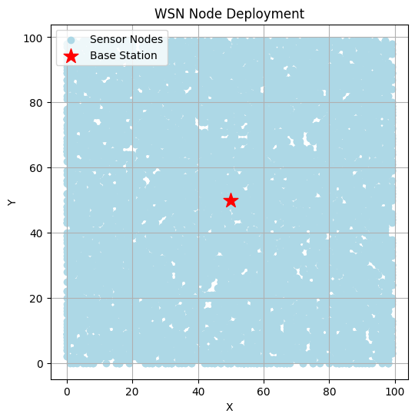

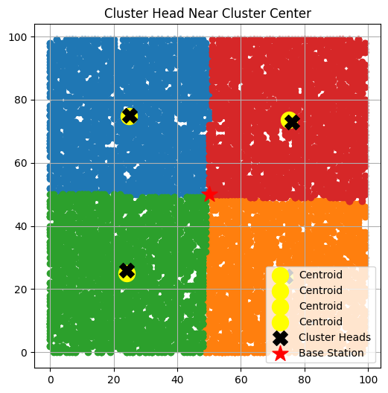

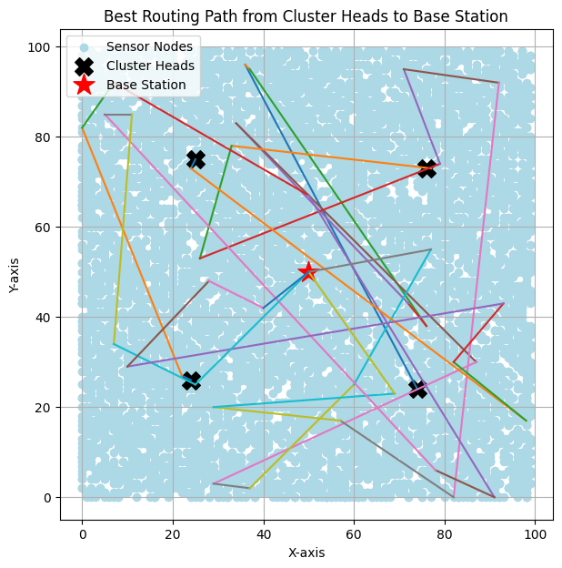

40
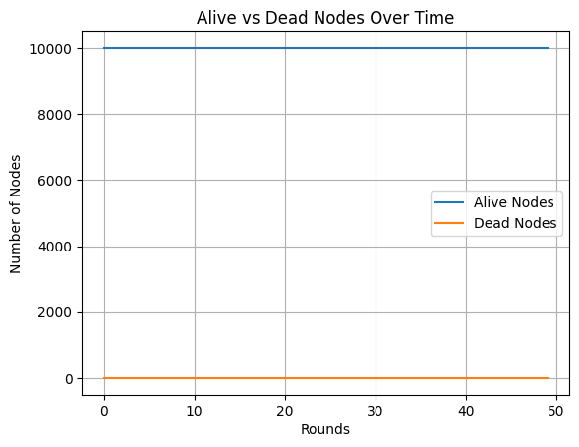

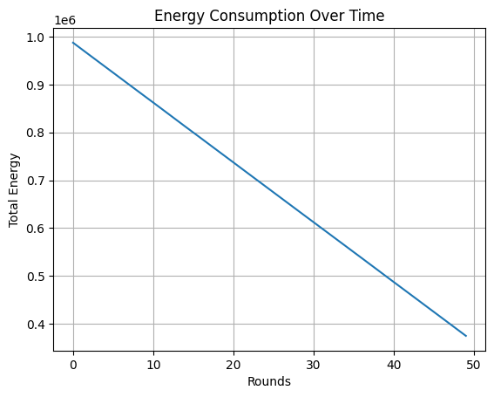

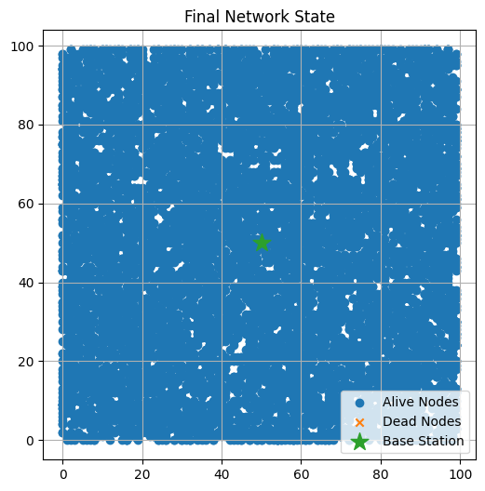

41
CHAPTER 10
REFERENCES

[1]Wan-Kyu Yun and Sang-Jo Yoo, ‘‘Q-Learning-Based Data-Aggregation-Aware Energy-Efficient Routing Protocol for Wireless Sensor Networks”, IEEE International conference,2021.
[2]Muhammad Akram, Sibghat Ullah Bazai, Muhammad Imran, “EEMLCR: Energy-Efficient Machine Learning-Based Clustering and Routing for Wireless Sensor Networks”, IEEE International conference,2025.
[3]Salim El Khediri, Awatef Benfradj, “Integration of artificial intelligence (AI) with sensor networks: Trends, challenges, and future directions”, Journal of King Saud University - Computer and Information Sciences,2024.
[4]Huda Salih Abd, Asaad S Daghul, “An Energy-Efficient Scheduling and Routing Protocol Based on Q-Learning for WSN”, Asian Journal of Computing and Engineering Technology,2025.
[5]Yan Wang, Ke Deng, Yongli Ren, Jeffrey Chan, “Reinforcement Learning for Tackling Energy-saving and Energy-balance Dilemma of Cluster-based Routing Protocols in WSNs”, IEEE International conference,2024.
[6]F. A. Khan, M. Khan, M. Asif, A. Khalid, and I. U. Haq, ‘‘Hybrid and multi-hop advanced zonal-stable election protocol for wireless sensor networks,’’ IEEE Access,2019.

42
[7]X. Li, J. Peng, J. Niu, F. Wu, J. Liao, and K. R. Choo, ‘‘A robust and energy efficient authentication protocol for industrial Internet of Things’’, Research Gate,2018.
[8]T.Hemalatha, M.V.Ramesh, and V.P.Rangan,‘‘Effective and accelerated forewarning of landslides using wireless sensor networks and machine learning,’’ IEEE Access,2025.
[9]S. M. Zahid, M. A. Jan, F. Khan, and M. Alam, ‘‘Energy-efficient cluster-based routing using machine learning techniques for wireless sensor networks,’’ IEEE Access, 2021.
[10]Y. Wang, K. Deng, Y. Ren, G. Tian, and C. S. Jensen, ‘‘Reinforcement learning for improving energy balance in cluster-based routing protocols of wireless sensor networks,’’ IEEE Access,2023.

43
CERTIFICATES

44

45

46

